#Assignment no.2
-Anushka Gaikwad

- Launched machine and started httpd
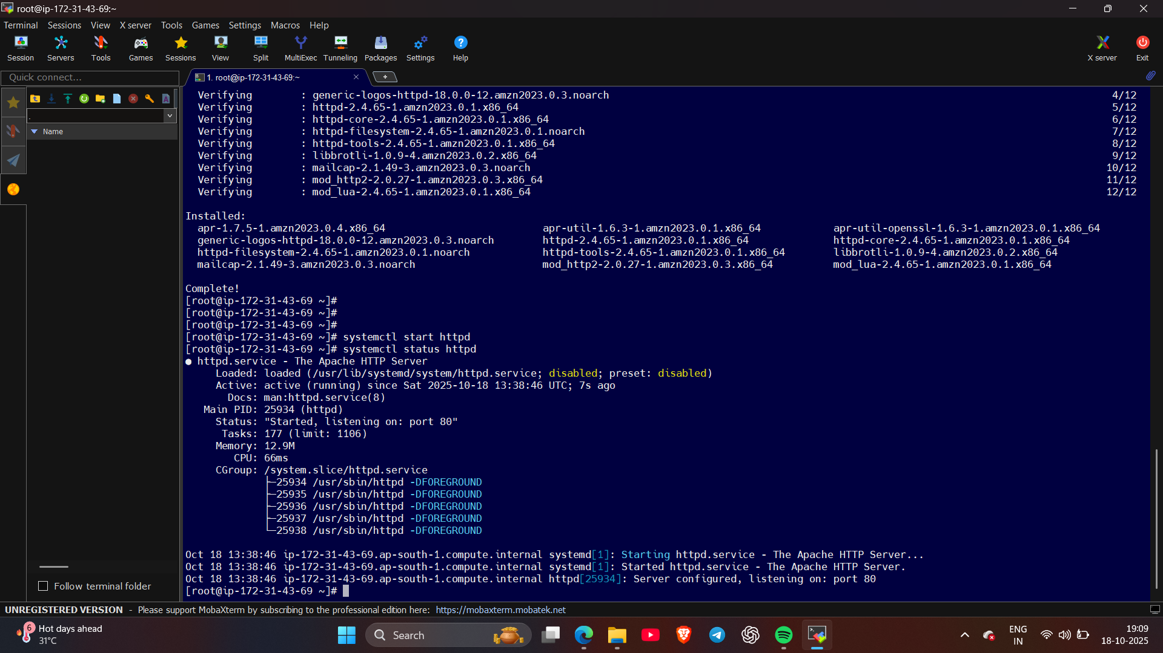
- Installed tomcat server and started it, also installed Jenkins warfile and deployed it
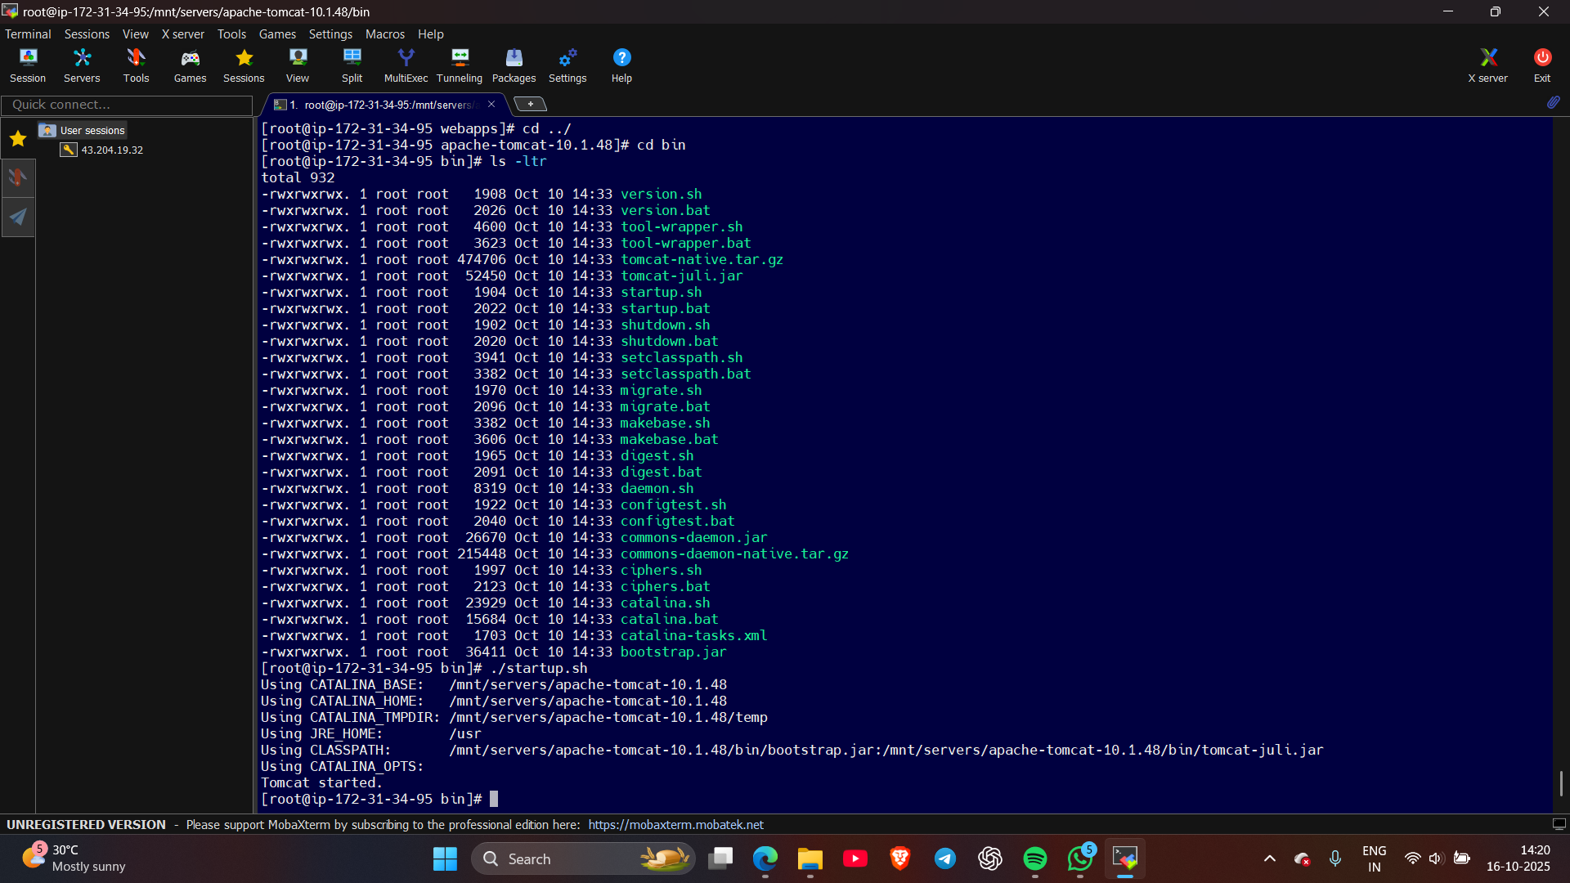

- Created repository 1 (pvt) and created index file in master branch
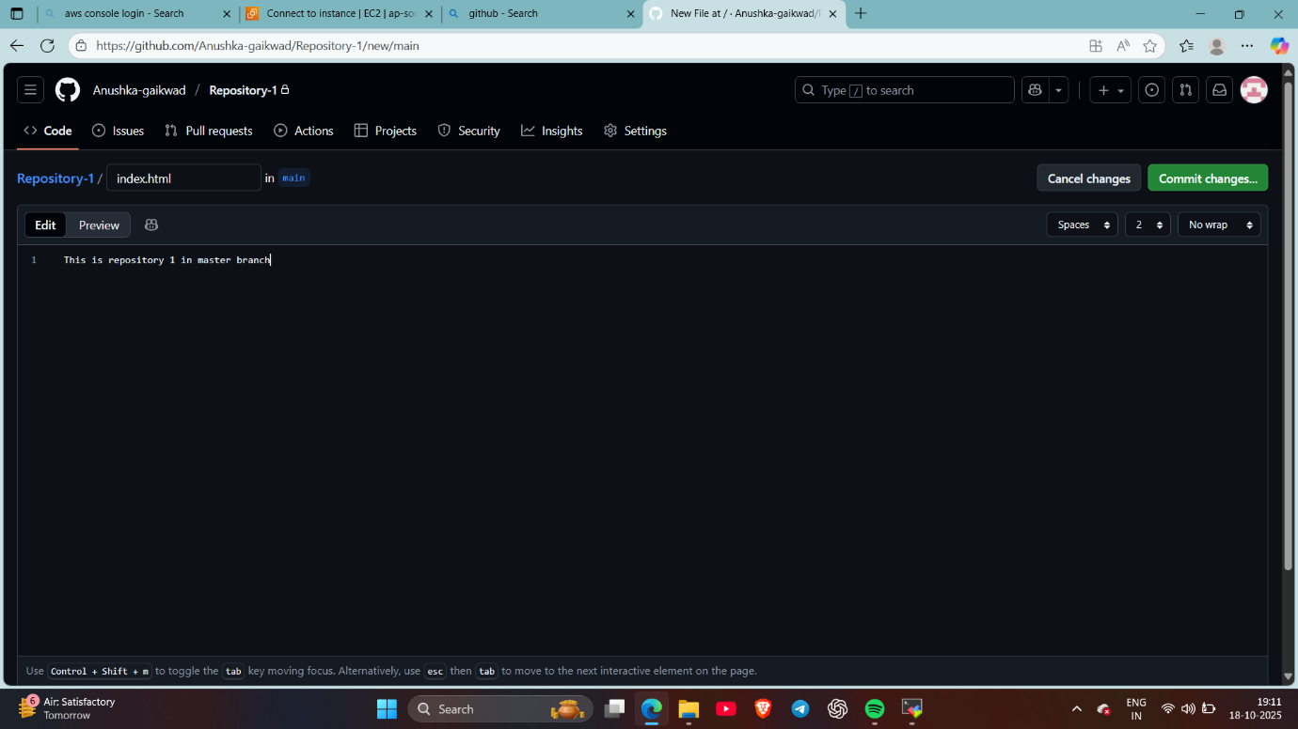
- Created repository 2 (pvt) and created index file in 2025Q1 branch
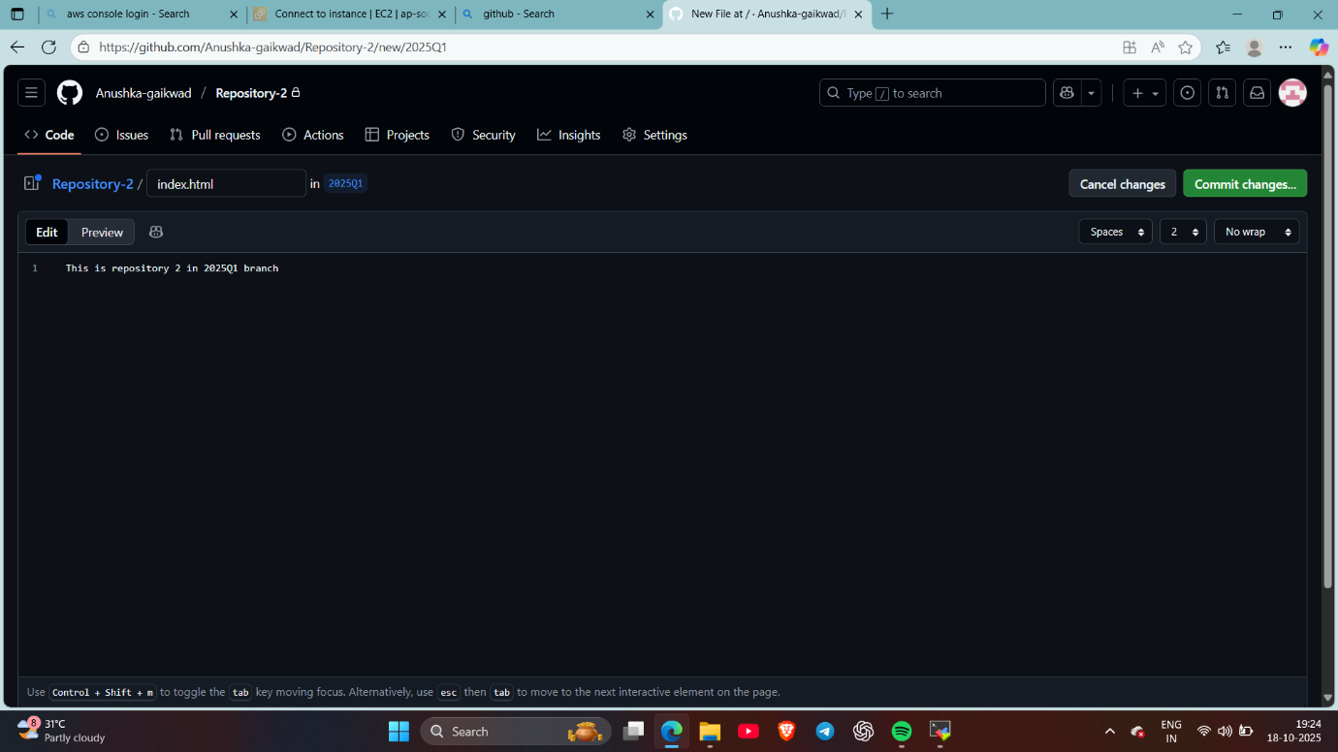

- Created repository 3 (pvt) and created index file in 2025Q2 branch
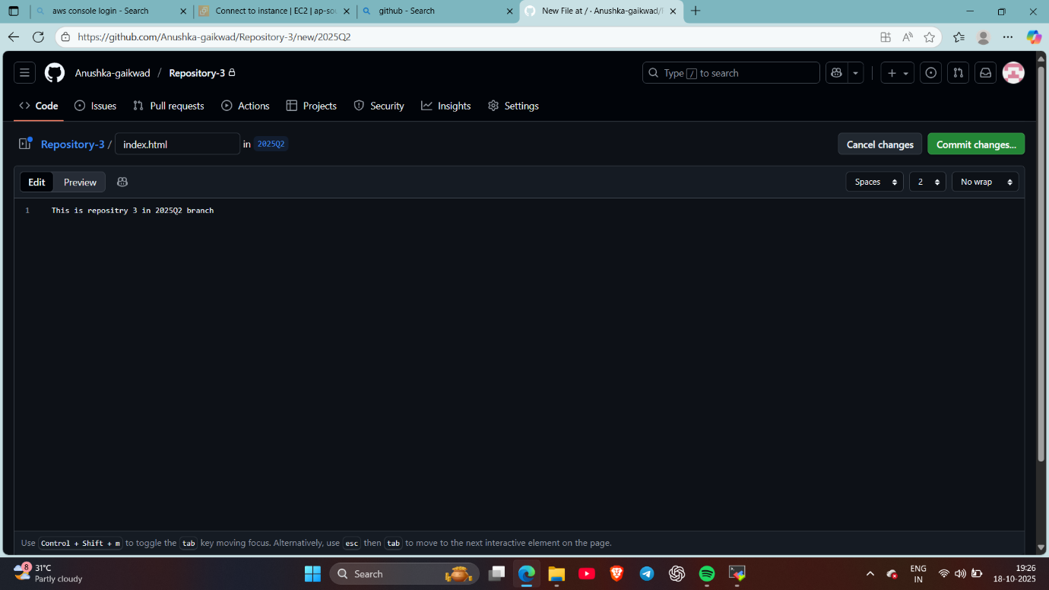
- Created 1st job in that I’ve put git’s pluggin and copied file from repo 1 in the specific html folder and maked sure that the workspace should be deleted before the next job
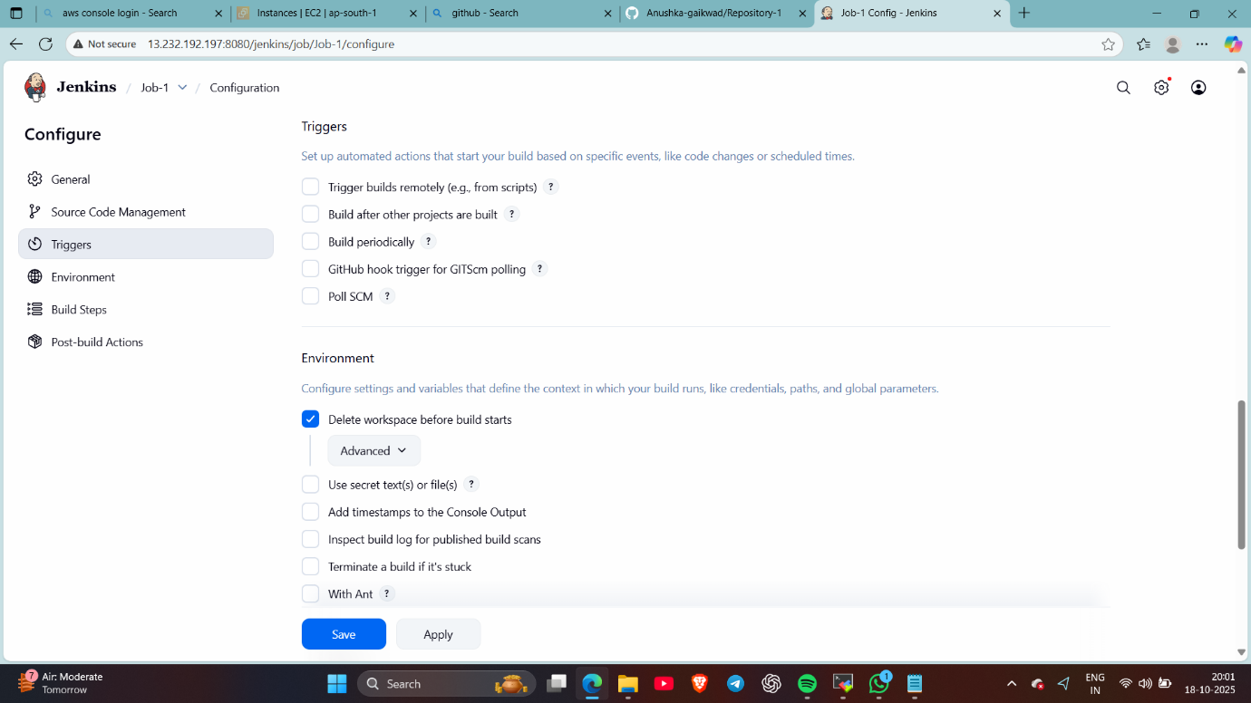
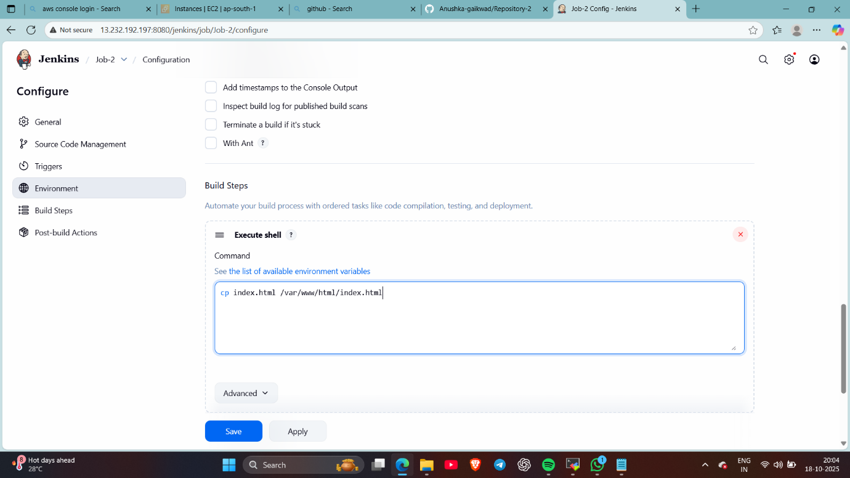
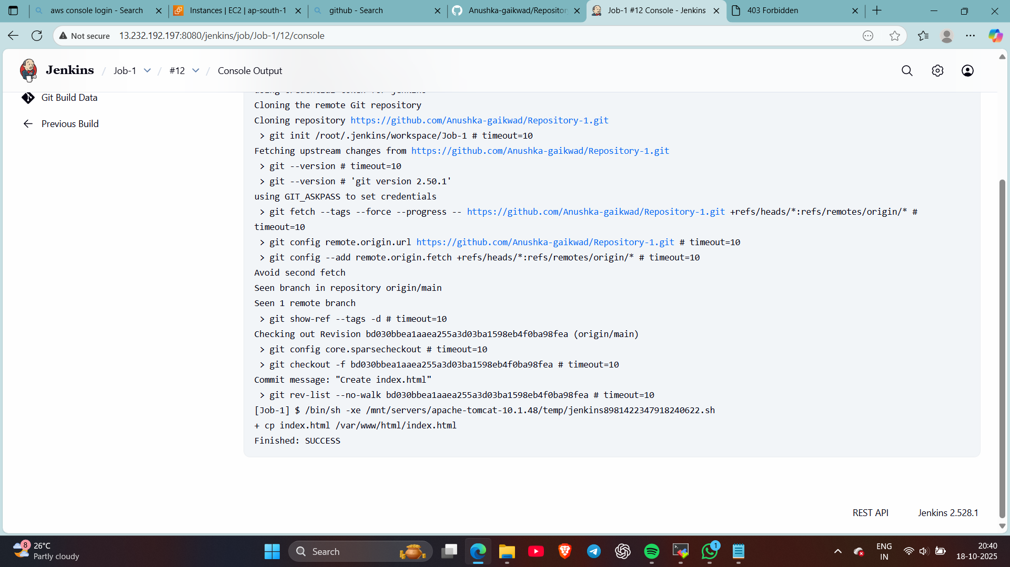
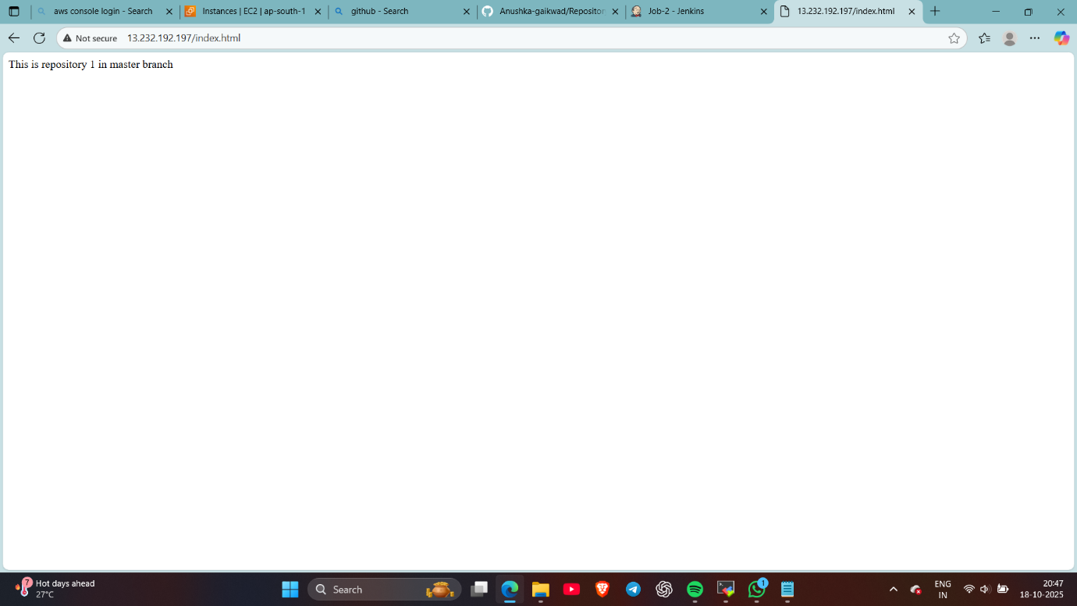
- Here, created job-2 , in this I’ve copied index html file from repo 2 , so when it will trigger repo 1’s index file will be deleted and repo 2’s file will be triggered
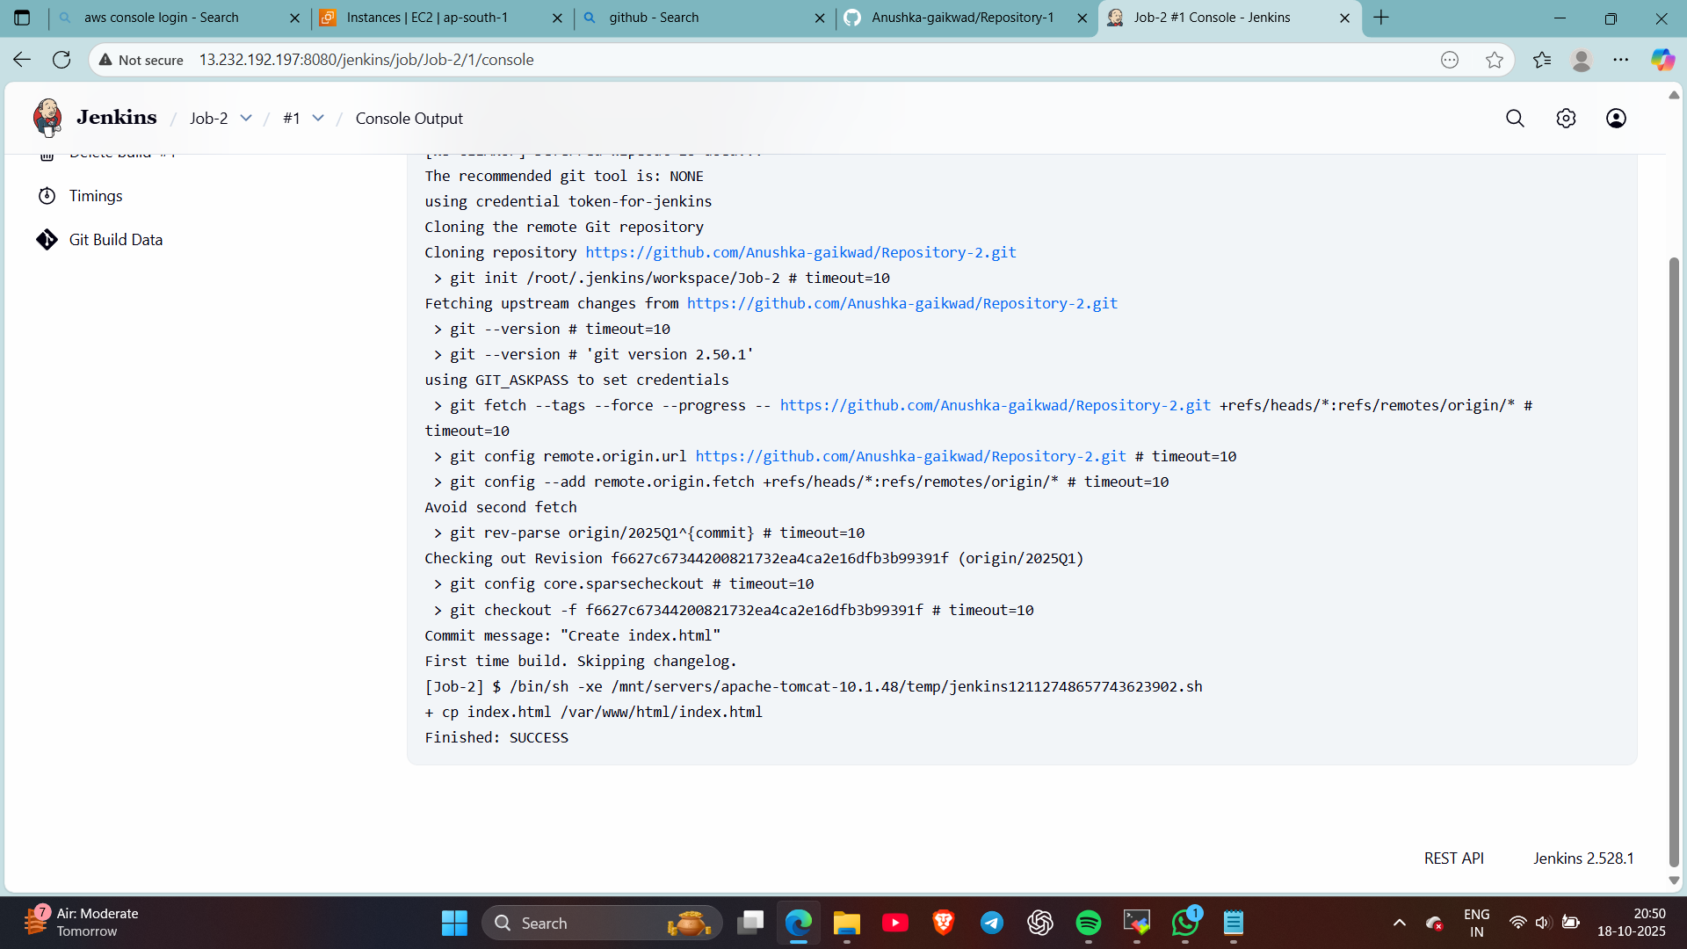
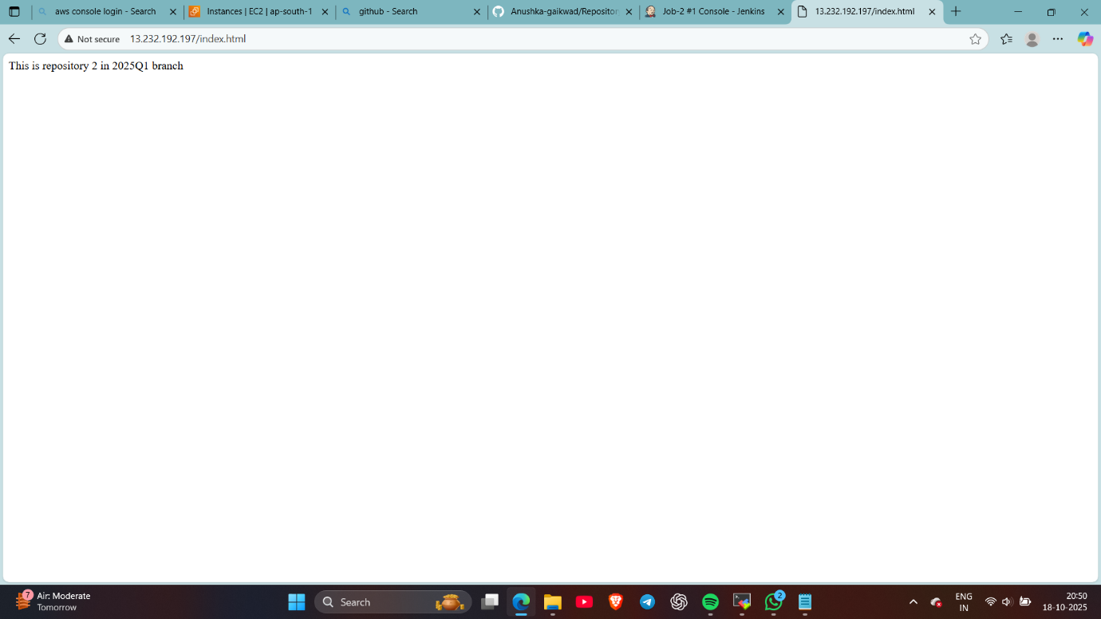

- Same for repo 3 : I’ve create job 3 and copied index file from repo 3 , when job 3 will build repo 2’s index file will be deleted and repo 3’s file will execute
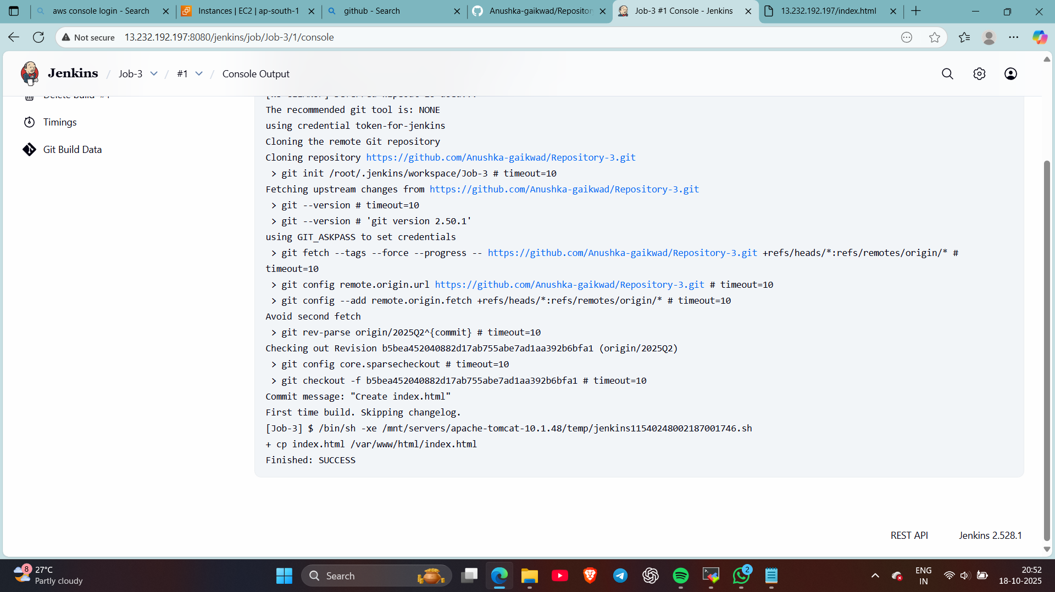
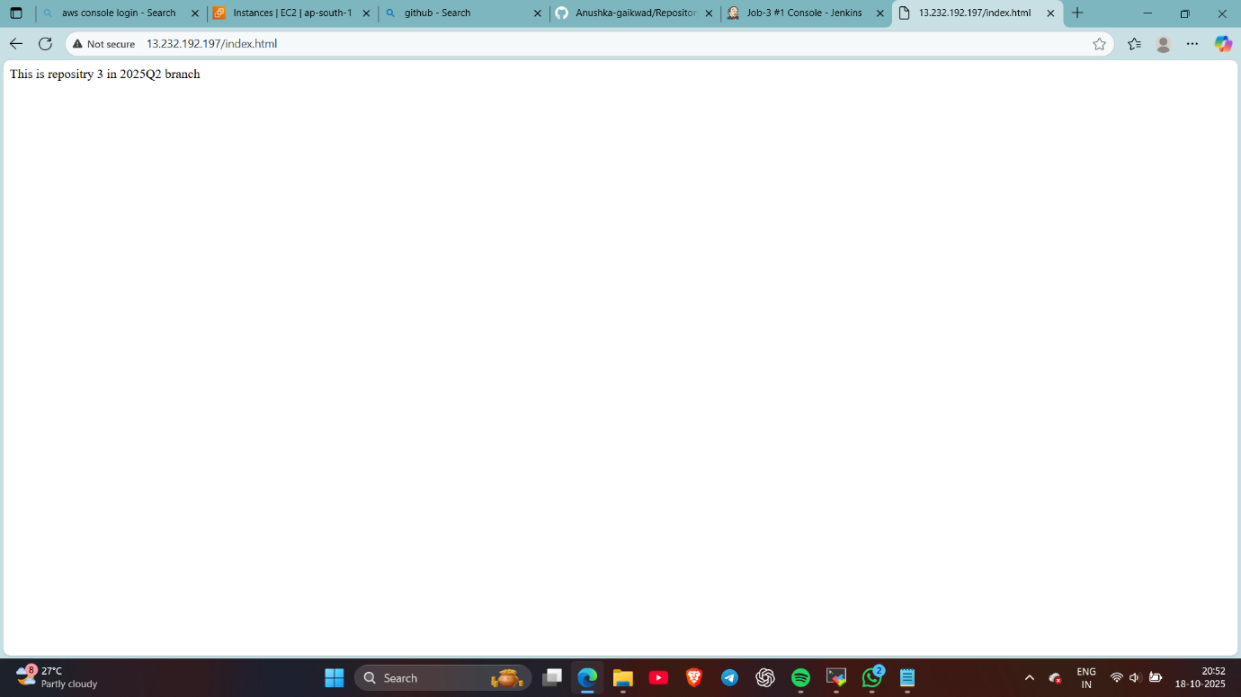

Thank you

